MGMS – Create Project

Detailed Design Document

Ver. 1.4

Version History
Date | Description
12-Oct-2010 | First Draft

Table of Contents

Version History 2
1 Introduction 4
2 Menu – Projects 4
2.1 Sub Menu – Add Projects 4
2.2 Sub menu - Projects List 5
2.2.1 Edit Projects 6
3 Associated tables 13
4 Data Dictionary 14

Introduction

This document provides the detailed design specifications for the Multisite Grant Management System project.

This is not a project plan nor does it detail the source code. It is a guide for system architecture and development, not for phasing, timelines or deliverables.

Finally, this is a ‘living document’ and the specification will change, continuously, as the project proceeds. More details will be added and the existing information edited as the requirements, architecture and design evolve in the course of the project.

Menu – Projects

The design discussed here are for the following:

The site admin can create new projects for the institution. The key associated requirements are:
- Saving the project details (which may be updated any number of times) - project name, code, type, Principal Investigator, Project Start & End Dates.
- The institution can assign any number of Co-PIs to the project after project creation.
- The institution can assign the created project to particular departments
- The site admin can allocate a grant amount for the created project (self-fund).

Sub Menu – Add Projects

Screen & Control Description

Any project created through this screen is automatically associated with the party with whose log-in details the user had logged into this application.

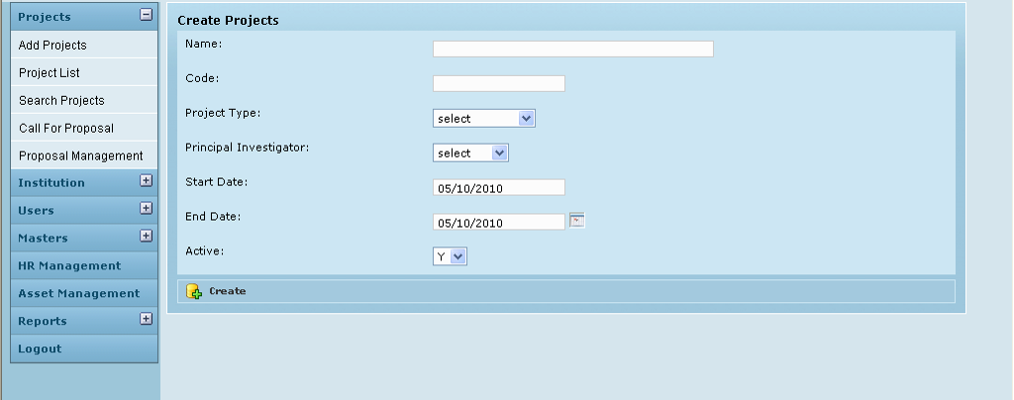

Field /Label | Input-Control | Data Type | Remarks / db table>field
Create Projects
Name: | Textbox | varchar(255) | projects>name
Code: | Textbox | varchar(255) | projects>code
Project Type: | Listbox | varchar(255); Int(11) | projects>project_type_id
Principal Investigator: | Listbox | varchar(255); | investigator>name  yes
Start Date: | Calendar | varchar(255); datetime | projects>project_start_date
End Date: | Calendar | varchar(255); datetime | projects>project>end_date
Active: | Listbox | Char(1) | projects>active_yes_no
Create | Button |  | On clicking, same screen refreshed with message “Project created successfully”

Sub menu - Projects List

When a site admin /privileged user logs into the GMS, “Projects List” is the home page by default and it lists out all the currently active projects in the user’s institution, and their details.

Screen & Control Description

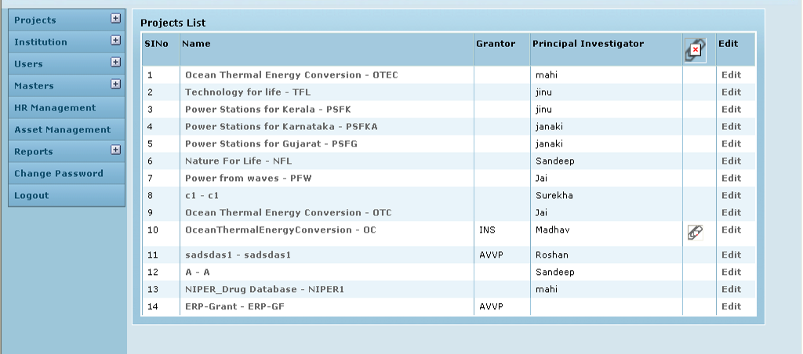

Projects List Table

Field /Label | Input-Control | Data Type | db table>field / Remarks
SlNo | Auto-populated | Auto-increment | Auto-increment
Name | Auto-populated, hyperlink | varchar(255) | [projects>name]<->[ projects>code]
Grantor | Auto-populated | varchar(255) | party>code
Principal Investigator | Auto-populated | varchar(255); | principal_investigator>name
Attachments | Icon | Image | attachments->domain->domain_id  eg for this screen domain in projects and domain_id is project_id
Edit | Button |  | On clicking, the “Edit Project” page opens

Clicking on each project name in the Projects List Table, will take the user to the specific project’s home page – Project Info page – discussed in a separate document

The other options to be filled in mandatorily while creating a project are:

Edit Projects

Screen & Control Description

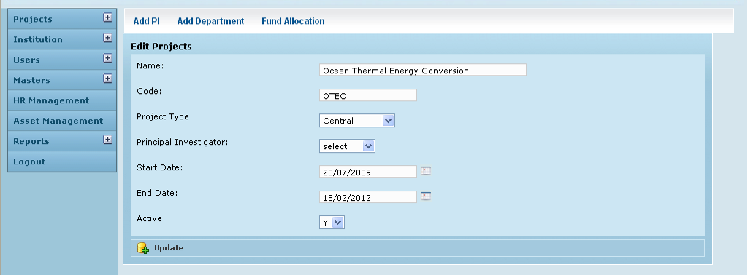

Field /Label | Input-Control | Data Type | Remarks / db table>field
Add PI | Button | Add PI screen opens up
Add Department | Button | Add Department screen opens up
Fund Allocation | Button | Fund Allocation screen opens up
Edit Projects
Name: | Textbox | varchar(255) | projects>name
Code: | Textbox | varchar(255) | projects>code
Project Type: | Listbox | varchar(255) | project_type>type
Principal Investigator: | Listbox | varchar(255) | investigator>name
Start Date: | Calendar | datetime | projects>project_start_date
End Date: | Calendar | datetime | projects>project_end_date
Active: | Listbox | char(1) | projects>active_yes_no
Update | Button |  | On clicking, the same page refreshes with message – “Project updated successfully”

Add PI

Through this screen, any number of co-Principal investigators may be added to a project, one after another. The name can be selected from a drop down list which is populated base on the list of names given in the master table.

Screen & Control Description

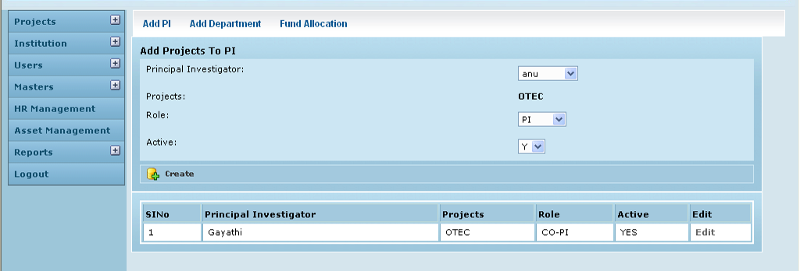

Field /Label | Input-Control | Data Type | Remarks / db table>field
Add PI | Button | Add PI screen opens up
Add Department | Button | Add Department screen opens up
Fund Allocation | Button | Fund Allocation screen opens up
Add Projects to PI
Principal Investigator: | Listbox | varchar(255); | investigator>name
Projects: | Autopopulated | varchar(255); | prjects>code
Role: | Listbox | varchar(255) | authority>authority
Active: | Listbox | char(1) | investigator>active_yes_no
Create | Button
(Table fields)
SlNo | Auto increment populated
Principal Investigator | Auto populated | varchar(255); | investigator>name
Projects | Auto populated | varchar(255); | prjects>code
Role | Auto populated | varchar(255) | authority>authority
Active | Auto populated | char(1) | investigator>active_yes_no
Edit | Button |  | On clicking, the “Edit Project PI map” page opens

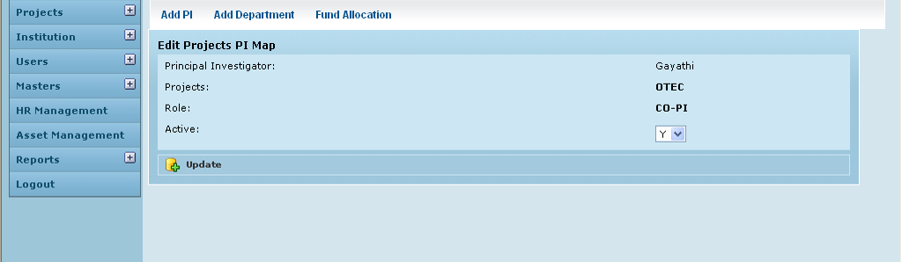

Field /Label | Input-Control | Data Type | Remarks / db table>field
Add PI | Button | Add PI screen opens up
Add Department | Button | Add Department screen opens up
Fund Allocation | Button | Fund Allocation screen opens up
Edit Projects PI Map
Principal Investigator | Auto populated | varchar(255); | investigator>name
Projects | Auto populated | varchar(255); | prjects>code
Role: | Auto populated | varchar(255) | authority>authority
Active: | Listbox | char(1) | investigator>active_yes_no
Update | Button |  | On clicking, the same page refreshes with message – “Project PI map updated successfully”

Add Department
Screen & Control Description

A project may or may not be mapped with different departments of the institution.

At present this relationship does not play an active role ion the workflow of MGMS.

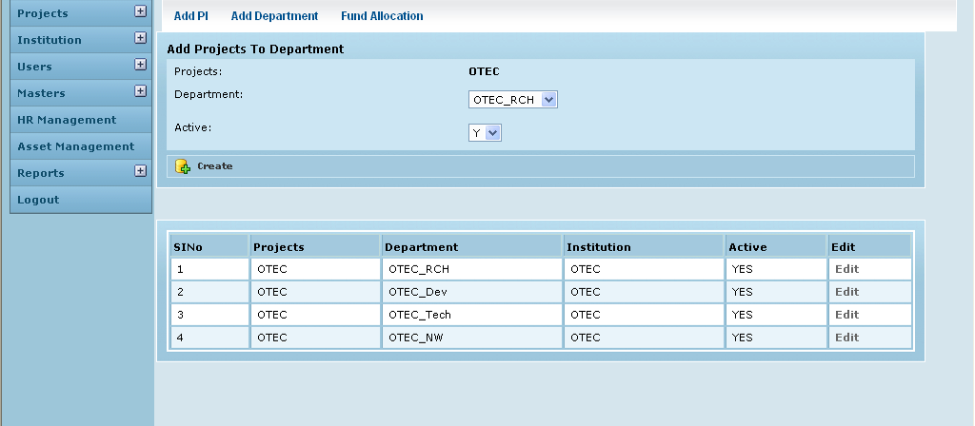

Field /Label | Input-Control | Data Type | Remarks / db table>field
Add PI | Button | Add PI screen opens up
Add Department | Button | Add Department screen opens up
Fund Allocation | Button | Fund Allocation screen opens up
Add Projects To Department
Projects: | Auto populated | varchar(255); | projects>code
Department: | Listbox | varchar(255); | party_department>department_code
Active: | Listbox | char(1) | projects_department_map>active_yes_no
Create | Button
(Table fields)
SlNo | Auto populated
Projects | Auto populated | varchar(255); | projects>code
Department | Auto populated | varchar(255); | party_department>department_code
Institution | Auto populated | varchar(255); | party>code
Active | Auto populated | char(1) | projects_department_map>active_yes_no
Edit | Button |  | On clicking, the “Edit Projects Department map” page opens

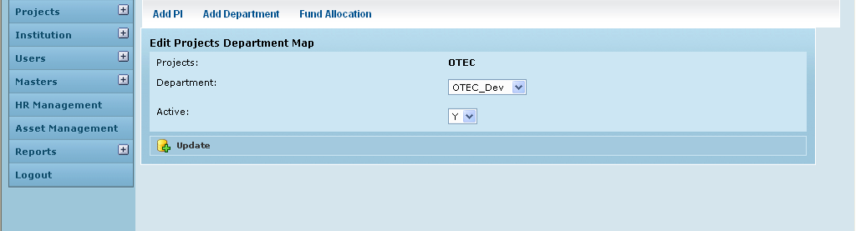

Field /Label | Input-Control | Data Type | Remarks / db table>field
Add PI | Button | Add PI screen opens up
Add Department | Button | Add Department screen opens up
Fund Allocation | Button | Fund Allocation screen opens up
Edit Projects Department Map
Projects: | Auto populated | varchar(255); | projects>code
Department: | Listbox | varchar(255); | party_department>department_code
Active: | Listbox | char(1) | projects_department_map>active_yes_no
Update | Button |  | On clicking, the same page refreshes with message – “Project department map updated successfully”

Grant Allocation

Here the grant amount allocated to the project is recorded. There are two scenarios:
- Self funding – the user’s own institution is allocating money to this project.
- Funded by a grantor – a project to be done in the user’s institution is being funded by a different institution.

Screen & Control Description

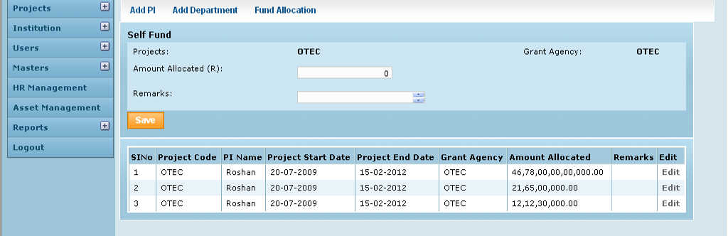

Field /Label | Input-Control | Data Type | Remarks / db table>field
Add PI | Button | Add PI screen opens up
Add Department | Button | Add Department screen opens up
Fund Allocation | Button | Fund Allocation screen opens up
Self Fund
Projects: | Auto populated | varchar(255) | projects>code
Grant Agency: | Auto populated | varchar(255) | party>code
Amount Allocated (R) | Textbox | double | grant_allocation>amount_allocated
Remarks: | Textarea | varchar(255) | grant_allocation>remarks
Save | Button
(Table fields)
SlNo | Auto increment populated
Project Code | Auto populated | varchar(255) | projects>code
PI Name | Auto populated | varchar(255) | investigator>name
Project Start Date | Auto populated | datetime | projects>project_start_date
Project End Date | Auto populated | datetime | projects>project_end_date
Grant Agency | Auto populated | varchar(255) | party>code
Amount allocated | Auto populated | double | grant_allocation>amount_allocated
Remarks | Auto populated | varchar(255) | grant_allocation>remarks
Edit | Button |  | On clicking, the “Edit Grant Allocation” page opens

Edit Grant Allocation

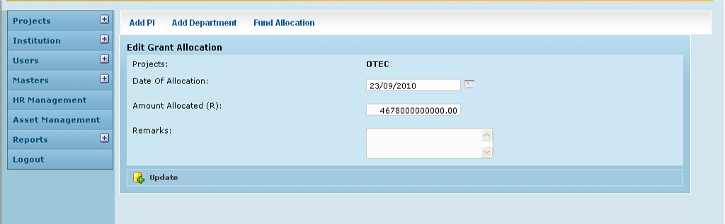

Field /Label | Input-Control | Data Type | Remarks / db table>field
Add PI | Button | Add PI screen opens up
Add Department | Button | Add Department screen opens up
Fund Allocation | Button | Fund Allocation screen opens up
Edit Grant Allocation
Projects: | Auto populated | varchar(255) | projects>code
Date of Allocation: | Calendar | datetime | grant_allocation>date_of_allocation
Amount allocated (R) | Textbox | double | grant_allocation>amount_allocated
Remarks | Textarea | varchar(255) | grant_allocation>remarks
Update | Button |  | On clicking, the same page refreshes with message – “Grant Allocation” updated successfully”

Associated tables

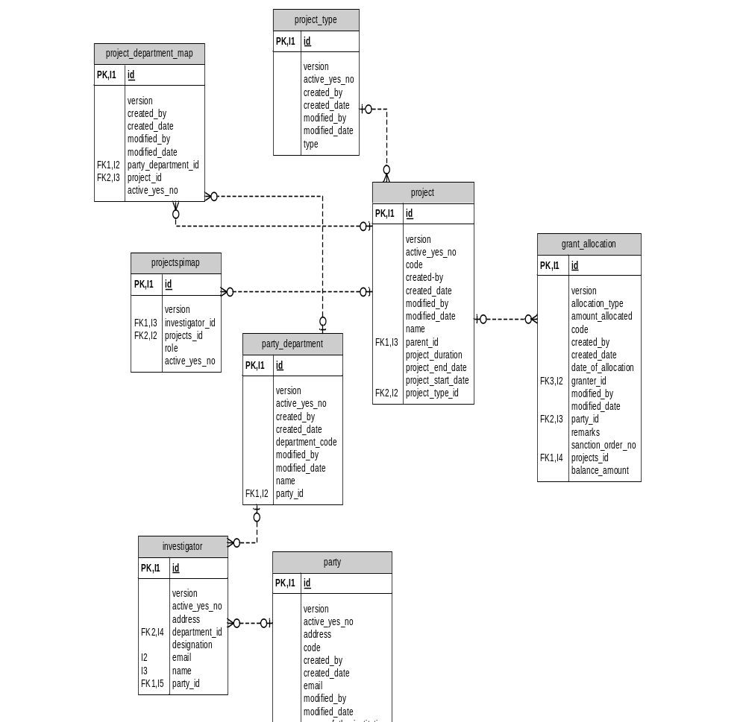

Data Dictionary

projects

Fields

Field | Type | Collation | Null | Key | Default | Extra | Privileges
id | bigint(20) | (NULL) | NO | PRI | (NULL) | auto_increment | select,insert,update,references
version | bigint(20) | (NULL) | NO |  |  |  | select,insert,update,references
active_yes_no | char(1) | latin1_swedish_ci | NO |  |  |  | select,insert,update,references
code | varchar(255) | latin1_swedish_ci | NO |  |  |  | select,insert,update,references
created_by | varchar(255) | latin1_swedish_ci | NO |  |  |  | select,insert,update,references
created_date | datetime | (NULL) | NO |  |  |  | select,insert,update,references
modified_by | varchar(255) | latin1_swedish_ci | NO |  |  |  | select,insert,update,references
modified_date | datetime | (NULL) | NO |  |  |  | select,insert,update,references
name | varchar(255) | latin1_swedish_ci | NO |  |  |  | select,insert,update,references
parent_id | bigint(20) | (NULL) | YES | MUL | (NULL) |  | select,insert,update,references
project_duration | varchar(255) | latin1_swedish_ci | YES |  | (NULL) |  | select,insert,update,references
project_end_date | datetime | (NULL) | YES |  | (NULL) |  | select,insert,update,references
project_start_date | datetime | (NULL) | YES |  | (NULL) |  | select,insert,update,references
project_type_id | int(11) | (NULL) | NO | MUL |  |  | select,insert,update,references

Indexes

Table | Non  unique | Key  name | Seq  in  index | Column  name | Collation | Cardinality | Sub  part | Packed | Null | Index  type | Comment
projects | 0 | PRIMARY | 1 | id | A | 137 | (NULL) | (NULL) |  | BTREE
projects | 1 | FKC479187A69DF6AED | 1 | project_type_id | A | 8 | (NULL) | (NULL) |  | BTREE
projects | 1 | FKC479187A43BA2D6A | 1 | parent_id | A | 137 | (NULL) | (NULL) | YES | BTREE

Foreign Key Relationships

FK Id | Reference Table | Source Column | Target Column | Extra Info
FKC479187A43BA2D6A | projects | `parent_id` | `id` | ,
FKC479187A69DF6AED | project_type | `project_type_id` | `id`

projectspimap

Fields

Field | Type | Collation | Null | Key | Default | Extra | Privileges | Comment
id | bigint(20) | (NULL) | NO | PRI | (NULL) | auto_increment | select,insert,update,references
version | bigint(20) | (NULL) | NO |  |  |  | select,insert,update,references
investigator_id | bigint(20) | (NULL) | NO | MUL |  |  | select,insert,update,references
projects_id | bigint(20) | (NULL) | NO | MUL |  |  | select,insert,update,references
role | varchar(255) | latin1_swedish_ci | NO |  |  |  | select,insert,update,references
active_yes_no | char(1) | latin1_swedish_ci | YES |  |  |  | select,insert,update,references

Indexes

Table | Non  unique | Key  name | Seq  in  index | Column  name | Collation | Cardinality | Sub  part | Packed | Null | Index  type | Comment
projectspimap | 0 | PRIMARY | 1 | id | A | 169 | (NULL) | (NULL) |  | BTREE
projectspimap | 1 | FKEA00CC89905C4B9A | 1 | projects_id | A | 169 | (NULL) | (NULL) |  | BTREE
projectspimap | 1 | FKEA00CC89893BB93A | 1 | investigator_id | A | 42 | (NULL) | (NULL) |  | BTREE

Foreign Key Relationships

FK Id | Reference Table | Source Column | Target Column | Extra Info
FKEA00CC89893BB93A | investigator | `investigator_id` | `id` | ,
FKEA00CC89905C4B9A | projects | `projects_id` | `id`

project_type

Fields

Field | Type | Collation | Null | Key | Default | Extra | Privileges | Comment
id | int(11) | (NULL) | NO | PRI | (NULL) | auto_increment | select,insert,update,references
version | bigint(20) | (NULL) | NO |  |  |  | select,insert,update,references
active_yes_no | char(1) | latin1_swedish_ci | NO |  |  |  | select,insert,update,references
created_by | varchar(255) | latin1_swedish_ci | NO |  |  |  | select,insert,update,references
created_date | datetime | (NULL) | NO |  |  |  | select,insert,update,references
modified_by | varchar(255) | latin1_swedish_ci | YES |  | (NULL) |  | select,insert,update,references
modified_date | datetime | (NULL) | YES |  | (NULL) |  | select,insert,update,references
type | varchar(255) | latin1_swedish_ci | NO |  |  |  | select,insert,update,references

Indexes

Table | Non  unique | Key  name | Seq  in  index | Column  name | Collation | Cardinality | Sub  part | Packed | Null | Index  type | Comment
project_type | 0 | PRIMARY | 1 | id | A | 8 | (NULL) | (NULL) |  | BTREE

project_department_map

Fields

Field | Type | Collation | Null | Key | Default | Extra | Privileges
id | bigint(20) | (NULL) | NO | PRI | (NULL) | auto_increment | select,insert,update,references
version | bigint(20) | (NULL) | NO |  |  |  | select,insert,update,references
created_by | varchar(255) | latin1_swedish_ci | YES |  | (NULL) |  | select,insert,update,references
created_date | datetime | (NULL) | YES |  | (NULL) |  | select,insert,update,references
modified_by | varchar(255) | latin1_swedish_ci | YES |  | (NULL) |  | select,insert,update,references
modified_date | datetime | (NULL) | YES |  | (NULL) |  | select,insert,update,references
party_department_id | bigint(20) | (NULL) | NO | MUL |  |  | select,insert,update,references
projects_id | bigint(20) | (NULL) | NO | MUL |  |  | select,insert,update,references
active_yes_no | char(1) | latin1_swedish_ci | YES |  |  |  | select,insert,update,references

Indexes

Table | Non  unique | Key  name | Seq  in  index | Column  name | Collation | Cardinality | Sub  part | Packed | Null | Index  type
project_  department_map | 0 | PRIMARY | 1 | id | A | 46 | (NULL) | (NULL) |  | BTREE
project_  department_map | 1 | FK4C808CD580CA8247 | 1 | party_  department_id | A | 23 | (NULL) | (NULL) |  | BTREE
project_  department_map | 1 | FK4C808CD5905C4B9A | 1 | projects_id | A | 46 | (NULL) | (NULL) |  | BTREE

Foreign Key Relationships

FK Id | Reference Table | Source Column | Target Column | Extra Info
FK4C808CD580CA8247 | party_department | `party_department_id` | `id` | ,
FK4C808CD5905C4B9A | projects | `projects_id` | `id`

party_department

Fields

Field | Type | Collation | Null | Key | Default | Extra | Privileges
id | bigint(20) | (NULL) | NO | PRI | (NULL) | auto_increment | select,insert,update,references
version | bigint(20) | (NULL) | NO |  |  |  | select,insert,update,references
active_yes_no | char(1) | latin1_swedish_ci | NO |  |  |  | select,insert,update,references
created_by | varchar(255) | latin1_swedish_ci | YES |  | (NULL) |  | select,insert,update,references
created_date | datetime | (NULL) | YES |  | (NULL) |  | select,insert,update,references
department_code | varchar(255) | latin1_swedish_ci | NO |  |  |  | select,insert,update,references
modified_by | varchar(255) | latin1_swedish_ci | YES |  | (NULL) |  | select,insert,update,references
modified_date | datetime | (NULL) | YES |  | (NULL) |  | select,insert,update,references
name | varchar(255) | latin1_swedish_ci | NO |  |  |  | select,insert,update,references
party_id | bigint(20) | (NULL) | NO | MUL |  |  | select,insert,update,references

Indexes

Table | Non  unique | Key  name | Seq  in  index | Column  name | Collation | Cardinality | Sub  part | Packed | Null | Index  type | Comment
party_department | 0 | PRIMARY | 1 | id | A | 27 | (NULL) | (NULL) |  | BTREE
party_department | 1 | FK7A7AD24B4B78CFDA | 1 | party_id | A | 27 | (NULL) | (NULL) |  | BTREE

Foreign Key Relationships

FK Id | Reference Table | Source Column | Target Column | Extra Info
FK7A7AD24B4B78CFDA | party | `party_id` | `id`

grant_allocation

Fields

Field | Type | Collation | Null | Key | Default | Extra | Privileges
id | bigint(20) | (NULL) | NO | PRI | (NULL) | auto_increment | select,insert,update,references
version | bigint(20) | (NULL) | NO |  |  |  | select,insert,update,references
allocation_type | varchar(255) | latin1_swedish_ci | NO |  |  |  | select,insert,update,references
amount_allocated | double | (NULL) | NO |  |  |  | select,insert,update,references
code | varchar(255) | latin1_swedish_ci | NO |  |  |  | select,insert,update,references
created_by | varchar(255) | latin1_swedish_ci | NO |  |  |  | select,insert,update,references
created_date | datetime | (NULL) | YES |  | (NULL) |  | select,insert,update,references
date_of_allocation | datetime | (NULL) | NO |  |  |  | select,insert,update,references
granter_id | bigint(20) | (NULL) | YES | MUL | (NULL) |  | select,insert,update,references
modified_by | varchar(255) | latin1_swedish_ci | NO |  |  |  | select,insert,update,references
modified_date | datetime | (NULL) | YES |  | (NULL) |  | select,insert,update,references
party_id | bigint(20) | (NULL) | NO | MUL |  |  | select,insert,update,references
projects_id | bigint(20) | (NULL) | NO | MUL |  |  | select,insert,update,references
remarks | varchar(255) | latin1_swedish_ci | NO |  |  |  | select,insert,update,references
sanction_order_no | varchar(255) | latin1_swedish_ci | YES |  | (NULL) |  | select,insert,update,references

Indexes

Table | Non  unique | Key  name | Seq  in  index | Column  name | Collation | Cardinality | Sub  part | Packed | Null | Index  type | Comment
grant_allocation | 0 | PRIMARY | 1 | id | A | 433 | (NULL) | (NULL) |  | BTREE
grant_allocation | 1 | FK221B5BE337914517 | 1 | granter_id | A | 48 | (NULL) | (NULL) | YES | BTREE
grant_allocation | 1 | FK221B5BE34B78CFDA | 1 | party_id | A | 108 | (NULL) | (NULL) |  | BTREE
grant_allocation | 1 | FK221B5BE3905C4B9A | 1 | projects_id | A | 433 | (NULL) | (NULL) |  | BTREE

Foreign Key Relationships

FK Id | Reference Table | Source Column | Target Column | Extra Info
FK221B5BE3905C4B9A | projects | `projects_id` | `id` | ,
FK221B5BE337914517 | party | `granter_id` | `id` | ,
FK221B5BE34B78CFDA | party | `party_id` | `id`

investigator

Fields

Field | Type | Collation | Null | Key | Default | Extra | Privileges | Comment
id | bigint(20) | (NULL) | NO | PRI | (NULL) | auto_increment | select,insert,update,references
version | bigint(20) | (NULL) | NO |  |  |  | select,insert,update,references
active_yes_no | char(1) | latin1_swedish_ci | NO |  |  |  | select,insert,update,references
address | varchar(255) | latin1_swedish_ci | NO |  |  |  | select,insert,update,references
department_id | bigint(20) | (NULL) | NO | MUL |  |  | select,insert,update,references
designation | varchar(255) | latin1_swedish_ci | NO |  |  |  | select,insert,update,references
email | varchar(255) | latin1_swedish_ci | NO | UNI |  |  | select,insert,update,references
name | varchar(255) | latin1_swedish_ci | NO | UNI |  |  | select,insert,update,references
party_id | bigint(20) | (NULL) | NO | MUL |  |  | select,insert,update,references

Indexes

Table | Non  unique | Key  name | Seq  in  index | Column  name | Collation | Cardinality | Sub  part | Packed | Null | Index  type | Comment
investigator | 0 | PRIMARY | 1 | id | A | 31 | (NULL) | (NULL) |  | BTREE
investigator | 0 | email | 1 | email | A | 31 | (NULL) | (NULL) |  | BTREE
investigator | 0 | name | 1 | name | A | 31 | (NULL) | (NULL) |  | BTREE
investigator | 1 | FK967BBBA99F389FE0 | 1 | department_id | A | 31 | (NULL) | (NULL) |  | BTREE
investigator | 1 | FK967BBBA94B78CFDA | 1 | party_id | A | 31 | (NULL) | (NULL) |  | BTREE

Foreign Key Relationships

FK Id | Reference Table | Source Column | Target Column | Extra Info
FK967BBBA94B78CFDA | party | `party_id` | `id` | ,
FK967BBBA99F389FE0 | party_department | `department_id` | `id`

